- Jessica Dress  Free pattern  Thanks for downloading this pattern. Barbara Dress pattern belongs to On the Cutting Floor website. You might use it for your personal projects or if you have a small business (no more than a 100 finished items)  Please contacting me if you have any questions about it. |  | On the cutting floor  Facebook.com/onthecuttingfloor  Twitter/onthecutfloor  Pinterest/thecuttingfloor

  - instructions

1.

1. Place front and back bodice together, right sides facing. Pin the sides, and sew along, including the pockets.

2. Close the shoulders

3. Place front and back bodice pieces together, right sides facing. Close the sides and the shoulders.

4. Place the facing and bodice together, right sides facing. Pin the neckline area and sew along.

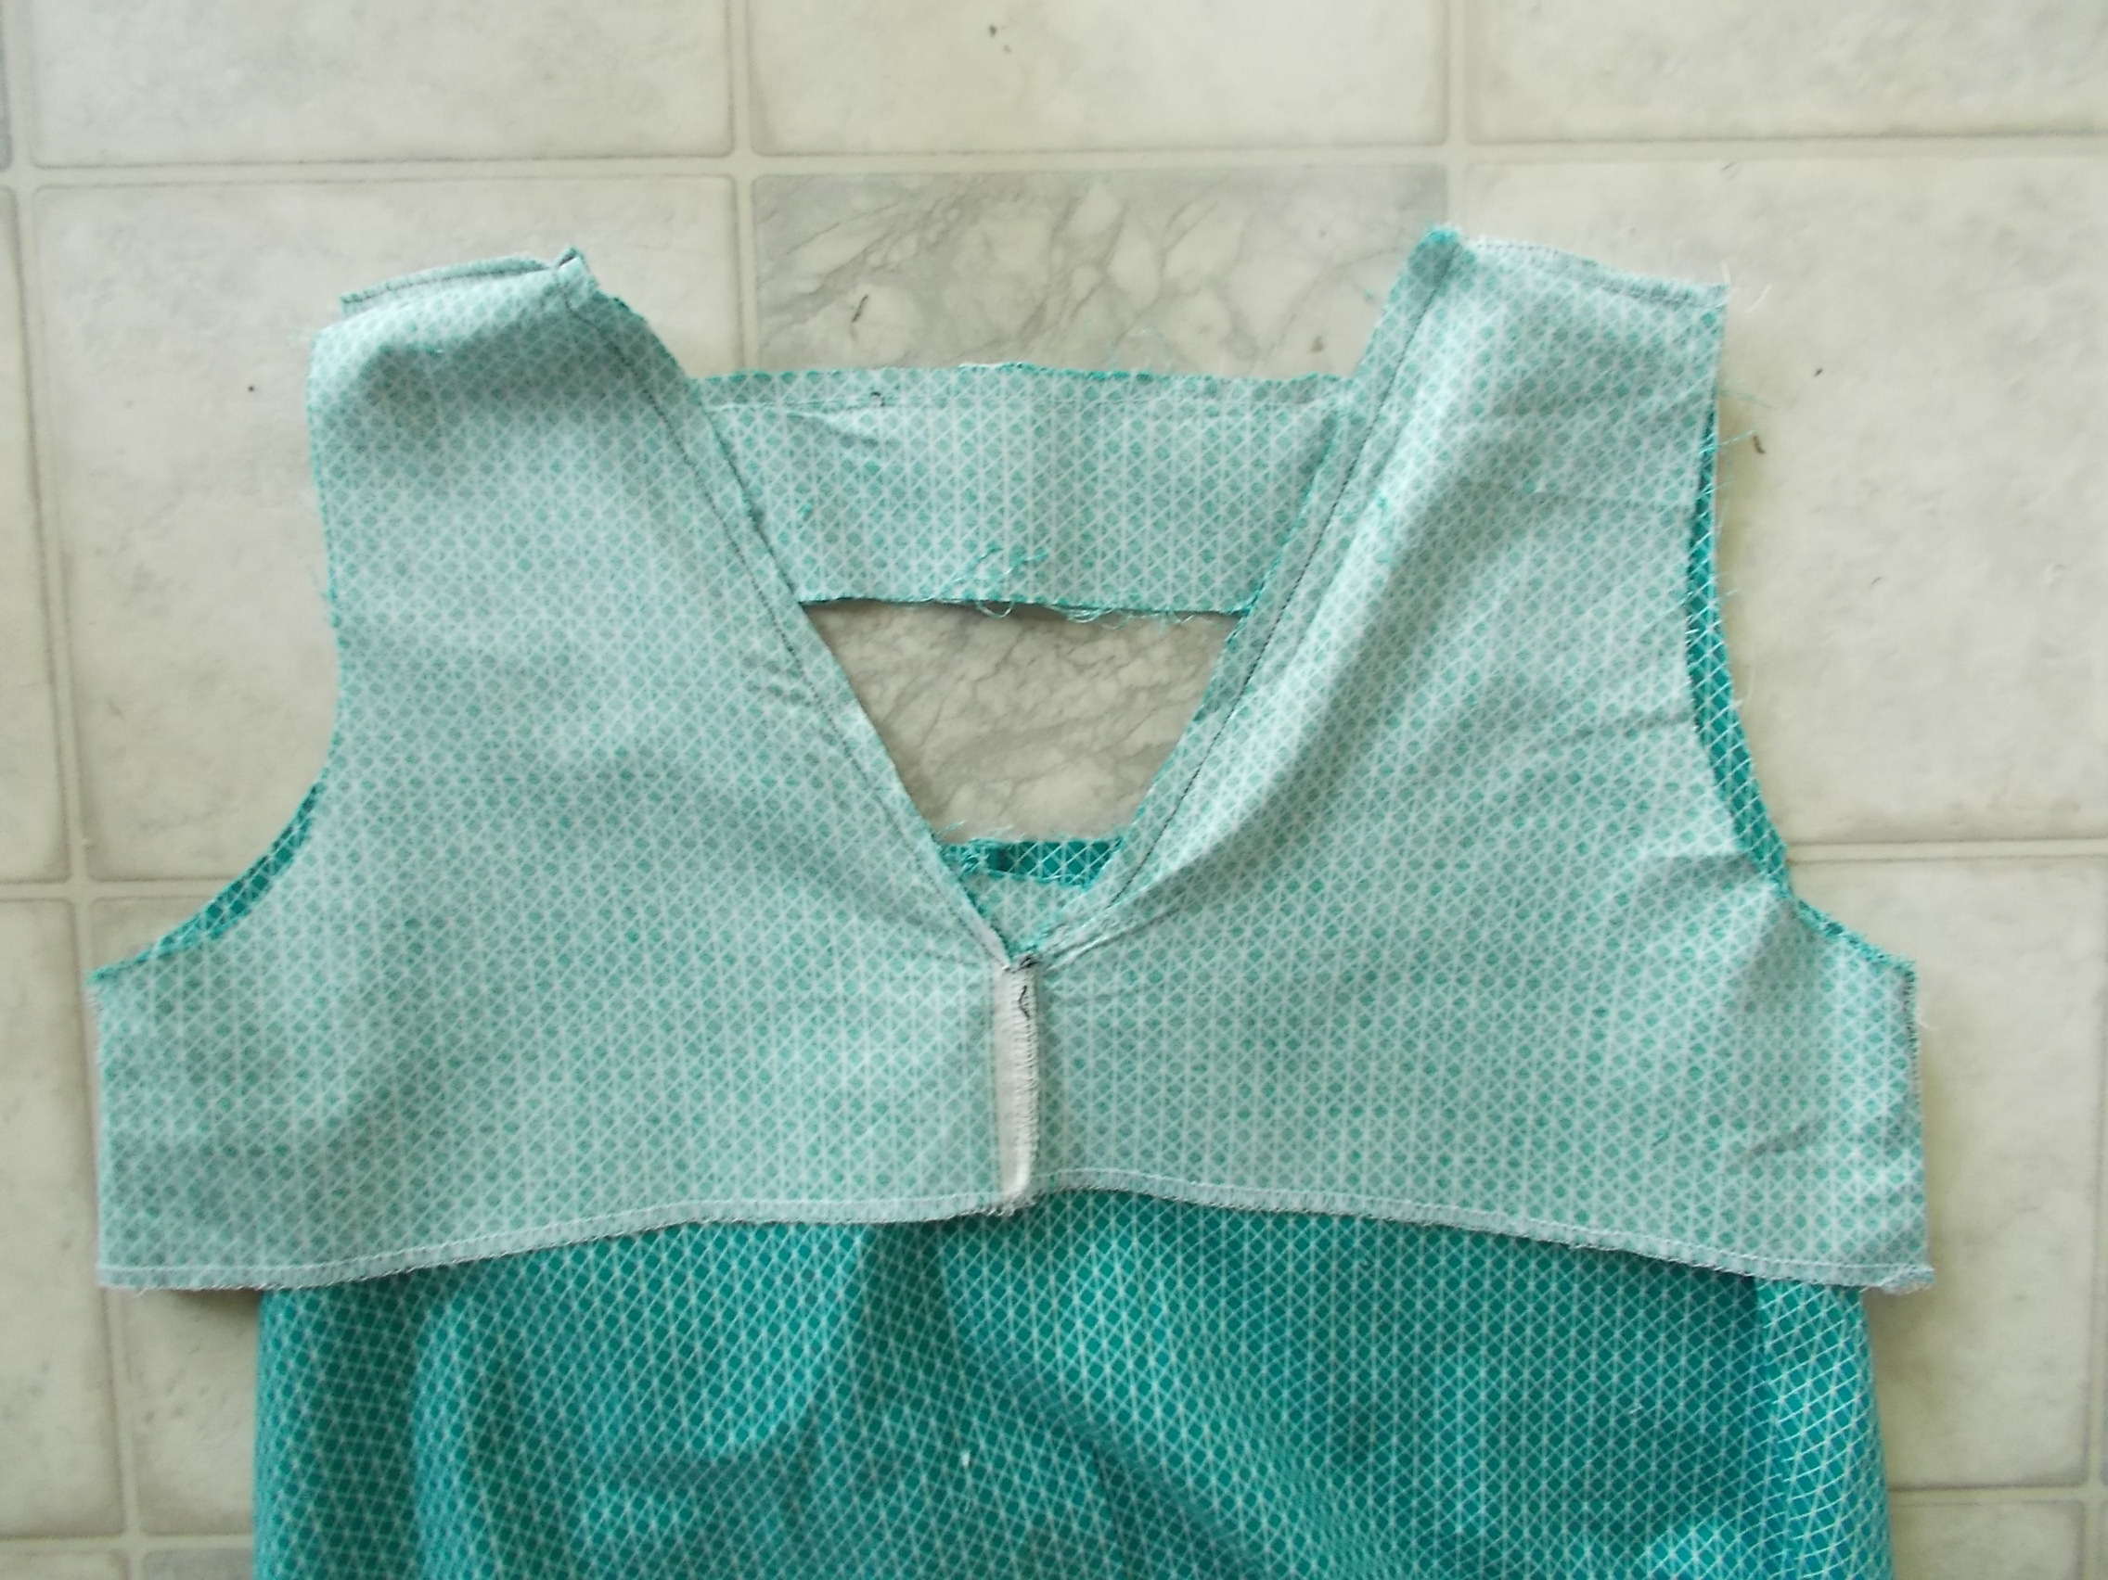

5. Trim the excess fabric on the neckline and create some notches as indicated in the following picture:

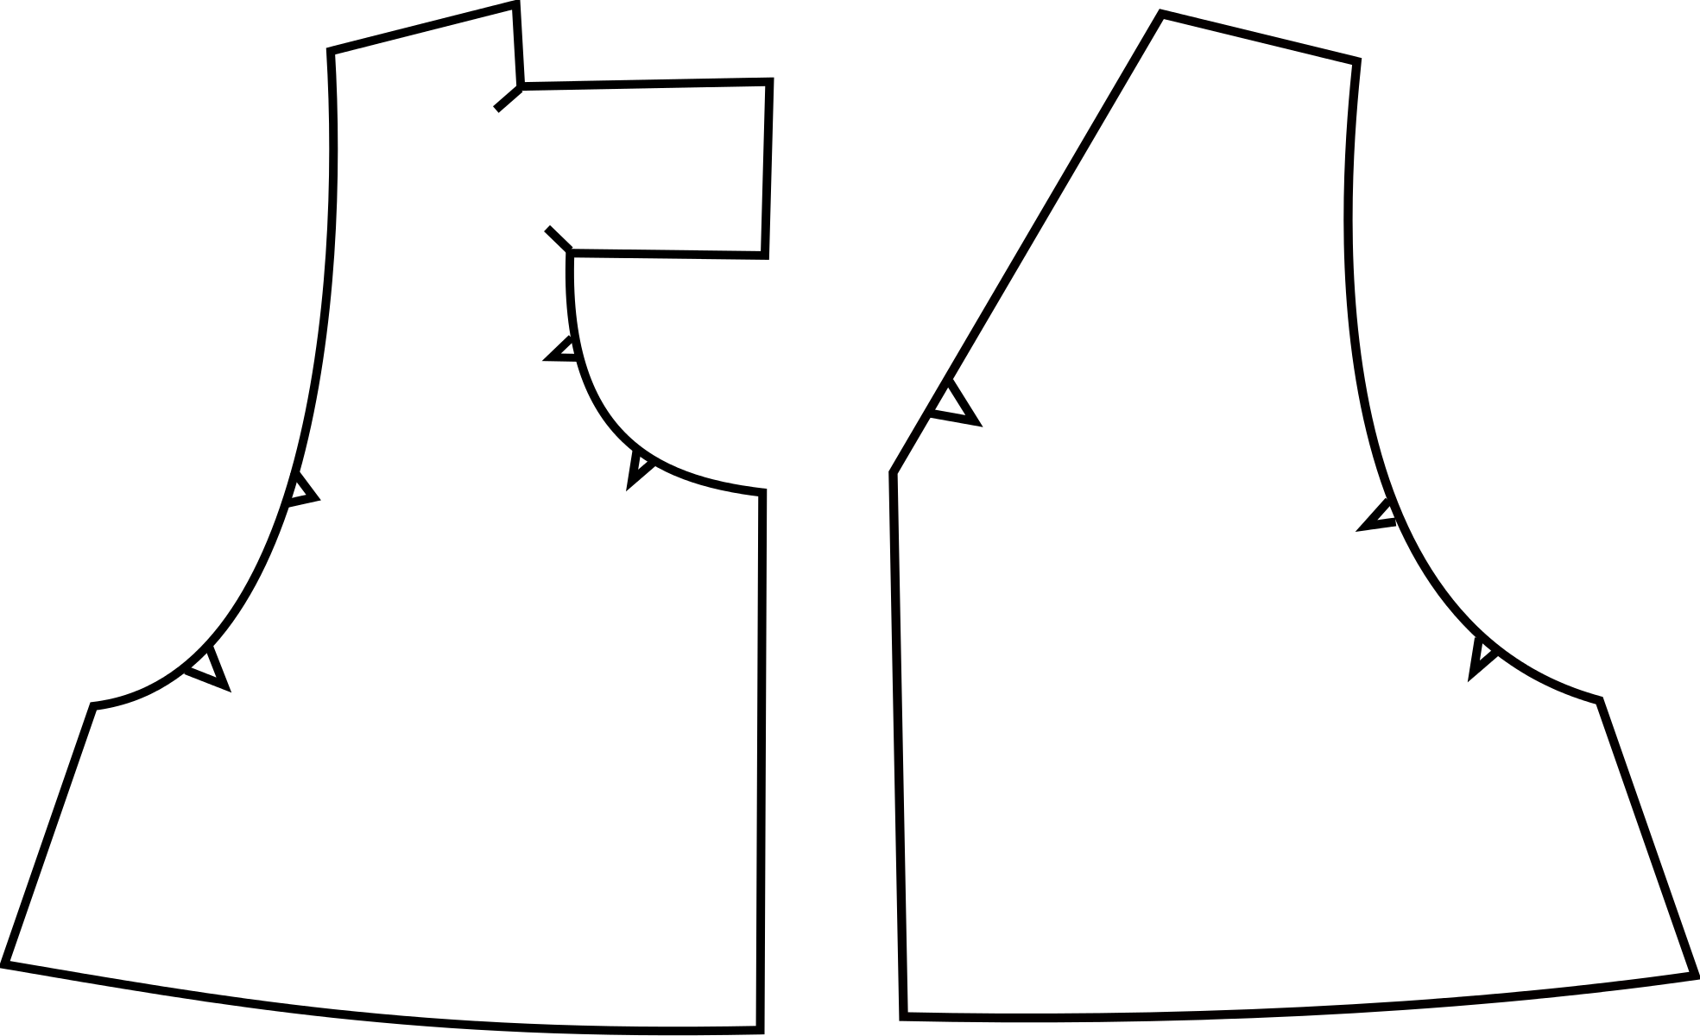

6. Turn around and press flat.
7. Top stich the neckline.

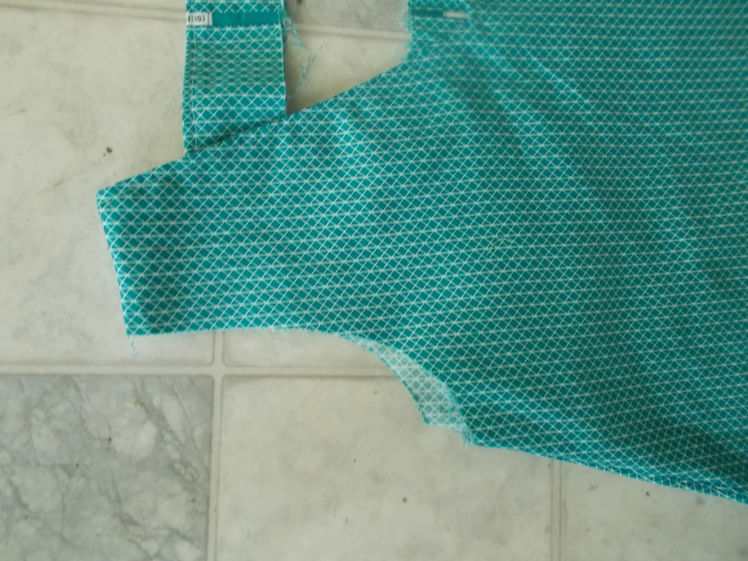

8. Make some notches on the back bodice and facing opening as indicated in the picture below:

9. Tuck in by ½ inch and pin the edges.

10. Sew along the edge.

11. Make some notches on the sleeves as indicated in the picture:

12. Tuck in by ½ inch and pin the bodice and facing armholes.
13. Sew along the area.

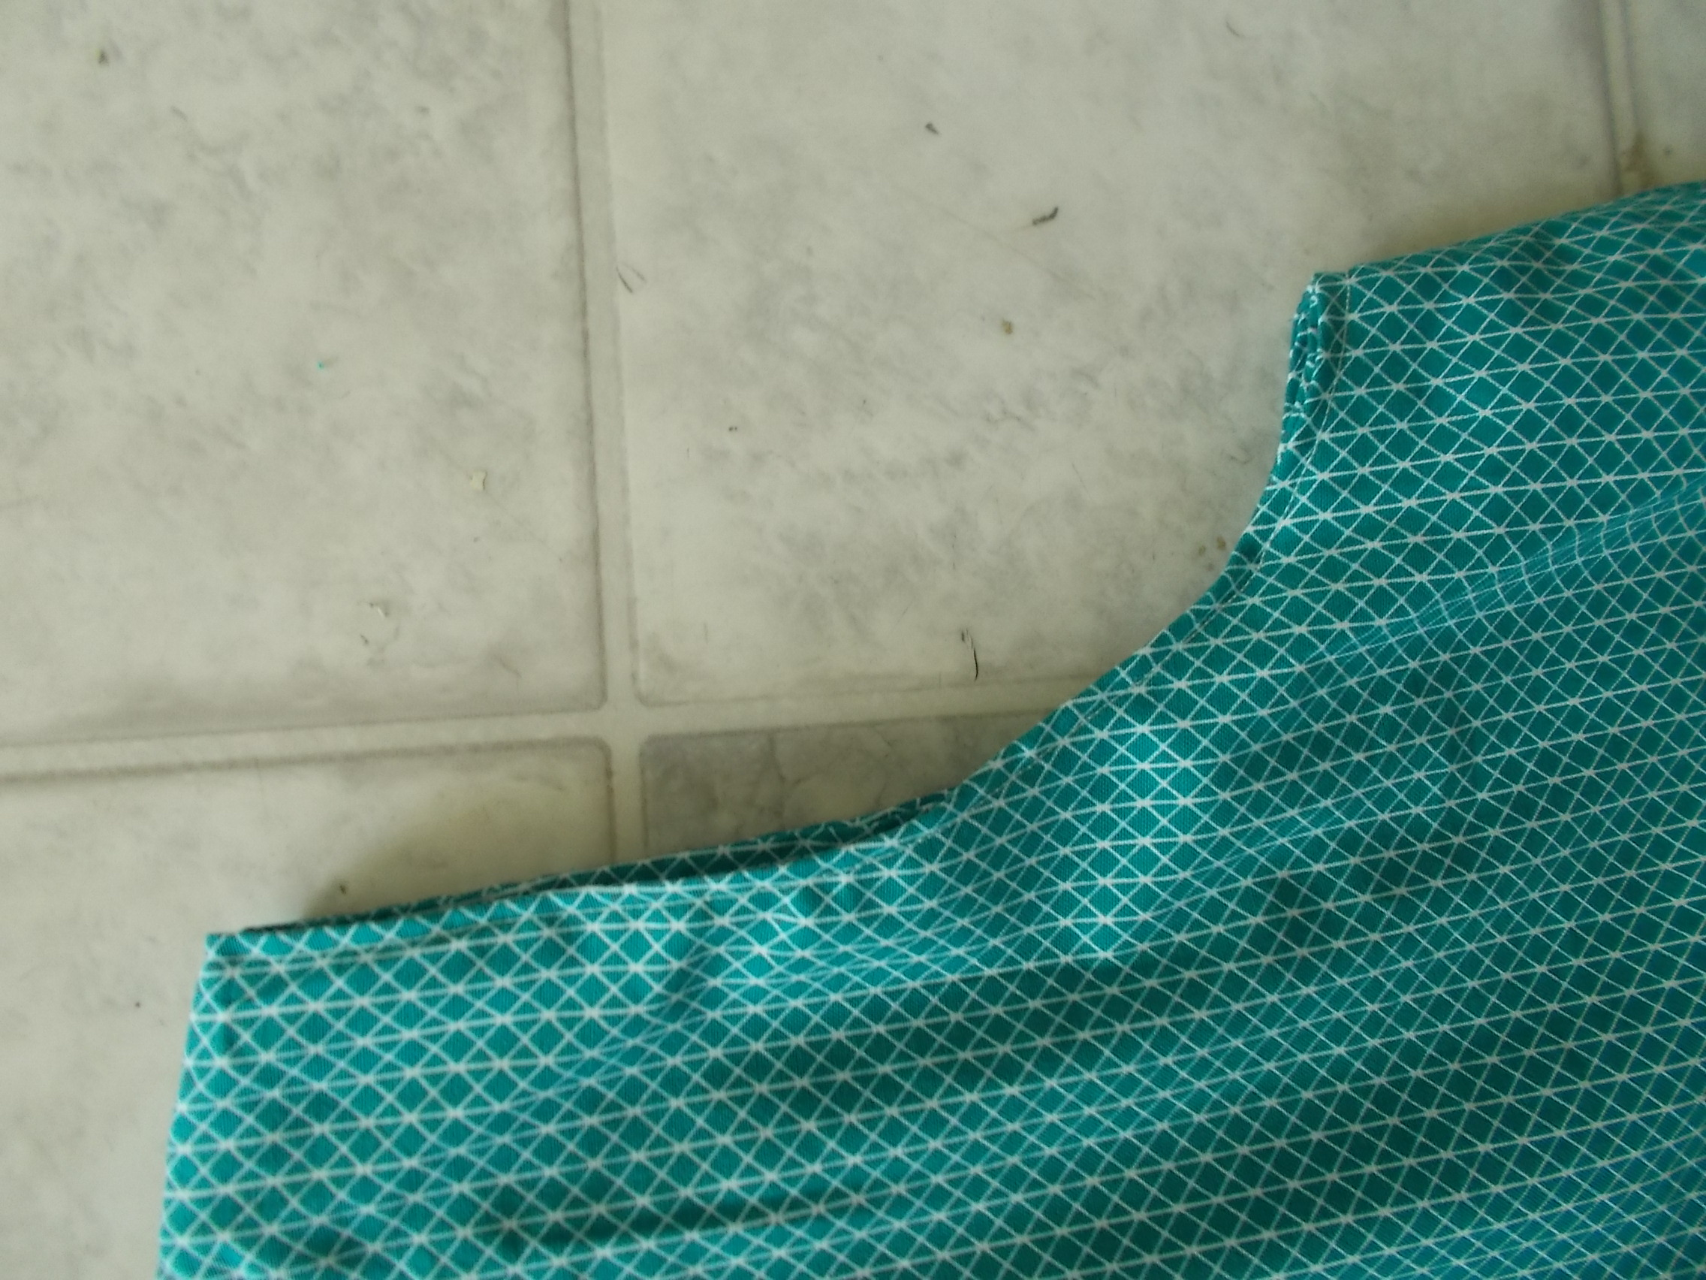

us
14. Make the shirred waistband by following the dotted lines in your pattern pieces. You should have 5 shirred lines, starting 1 inch above the pocket. They must be separated by ½ inch.

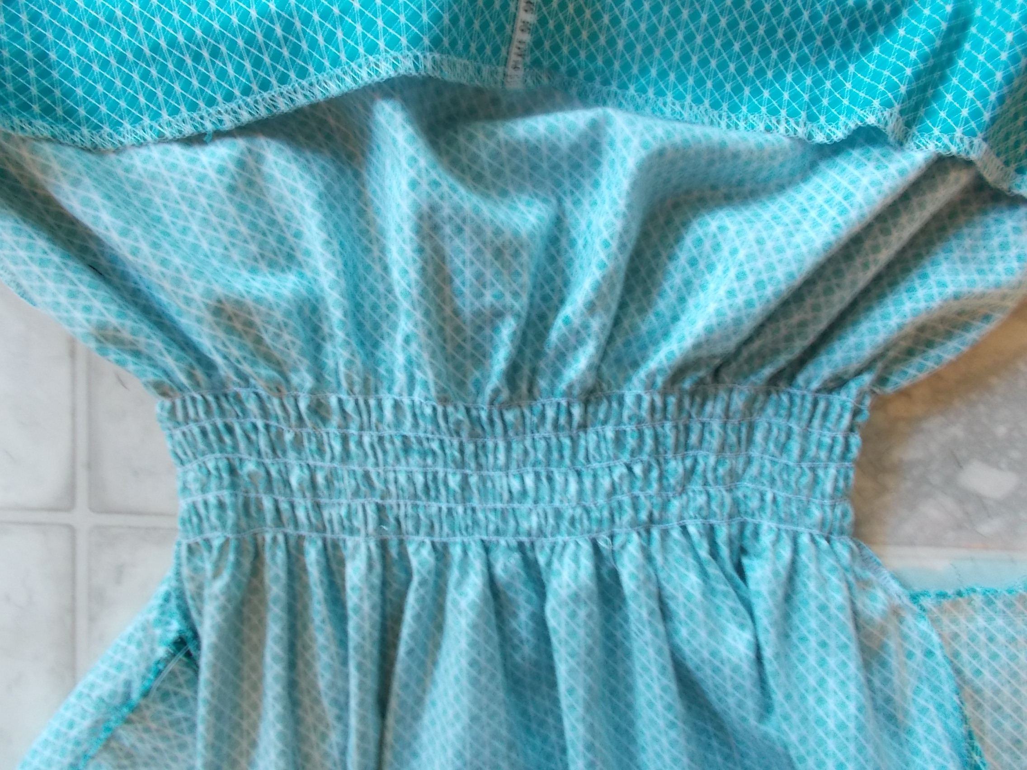

15. Finish your dress by making a ½ inch hemline.

